**Table of contents**

- Business rules 1

- ERD diagram 3

-SQL 4

-PLSQL 5

-Bash script 5

-Java application 6

-Validations and alerts 16

# **- Business rules**

I tried to generate business rules which are suitable for our case

I tried to make it easy to deal with the database but also without ignoring any logical constraint or restriction .

At the end I created a schema which consists of 5 tables (

Student , Course , Department , Grade , Enrollment )

Student :

1 – Each student can enroll in multiple courses

1. Each student has ( student_id , student_name , email , address , phone_mobile , date of birth, gpa )

2 -Course :

1 – Each course can be enrolled by multiple students

3 – Each course has (course_id , course_name , department_id , credit_hours)

3-Department :

1. Each department can provide multiple courses
2. Each department has (department_id , department_name )

4 –Grade :

1 – it has only the letters of each grade

4 - Enrollment :

1 – Each student can get many grades on many courses

2 – Each course can get many grades by many students

3 - each grade can be getting by many students in many courses

4 – it has( student_id , course_id , grade)

# **- ERD diagram**

Here is how I imagined the relations between the different entities in the database :

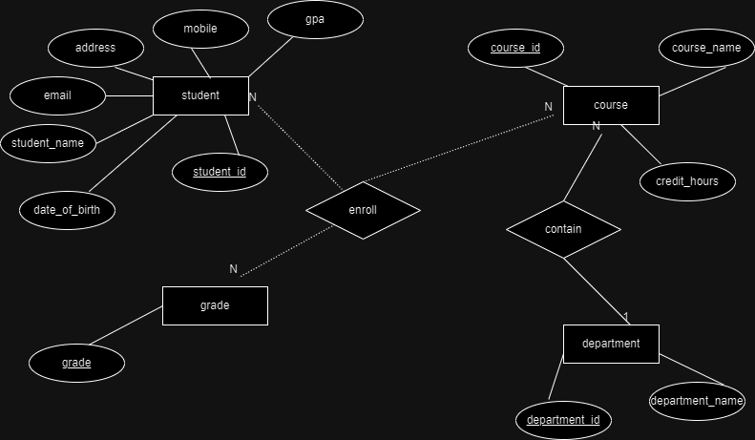

* And then I tried to create a mapping for this database which is also at the third normal form :

1. – Student : ( student_id (pk), student_name , email , address , phone_mobile , data_of_birth , gpa )
2. - Course : ( course_id(pk) , course_name , department_id (fk) , credit_hours )
3. – Department : (department_id (pk) , course_name )
4. – Grade : (grade (pk))
5. Enrollment : (( student_id(fk) , course_id (fk) )(pk), grade)

# **-SQL**

- I implemented the schema on mysql and populated it with sample data and validated the constraints like :

1 – you can not add a course with a department_id that does not exist in department table

2- You can not add enrollment with student_id that does not exist in student table

3- You can not add enrollment with course_id that does not exist in course table

4- You can not add enrollment with grade that does not exist in grade table

-I created script which is responsible for selecting courses names and calculating the number of students who enrolled in each course and the average gpa of total students by each course .. and I used this script to display a report in the java application later .

# **-PLSQL**

- I created A trigger (update_gpa) which counts the current gpa for each student based on any insertion happens in enrollment table .. it calculates total hours and total points and at the end it updates the gpa value in student table

- I created a procedure (update_student) and used it for for updating student’s information

- I also created a procedure (update_course) and used it for updating course’s information

# **-Bash script**

1 **-**I created a script called (database_backup) , opened it using git bash , modified its permissions , ran it using git bash to save a copy from the project’s database and I got a sql script at the end

2- I created a script called (second_task_bash )and ran it using git bash to monitor disk space and send alert if it exceeds a specific percentage

# **-Java application**

Students scene :

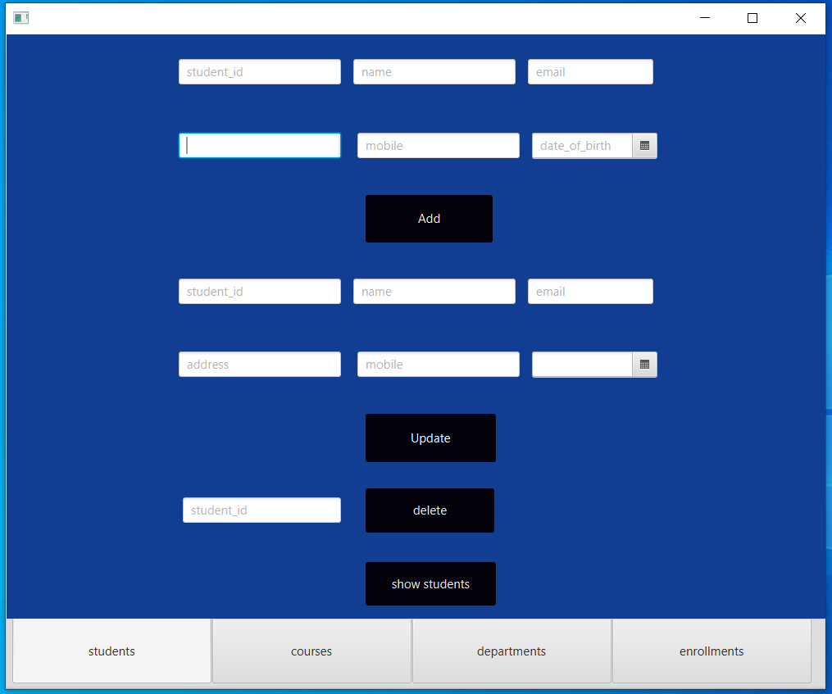

You can add , update and delete any student .. and you can also show students data using show students button which will redirects you to this scene :

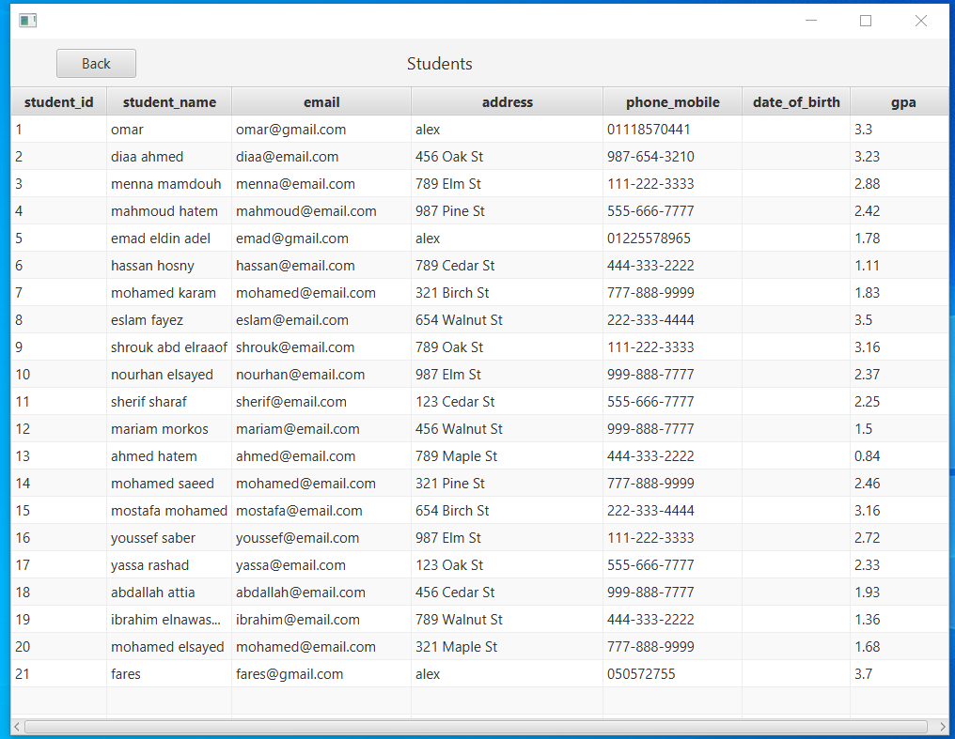

Courses scene :

You can add , update and delete any course .. and you can also show courses data using show courses button which will redirects you to this scene :

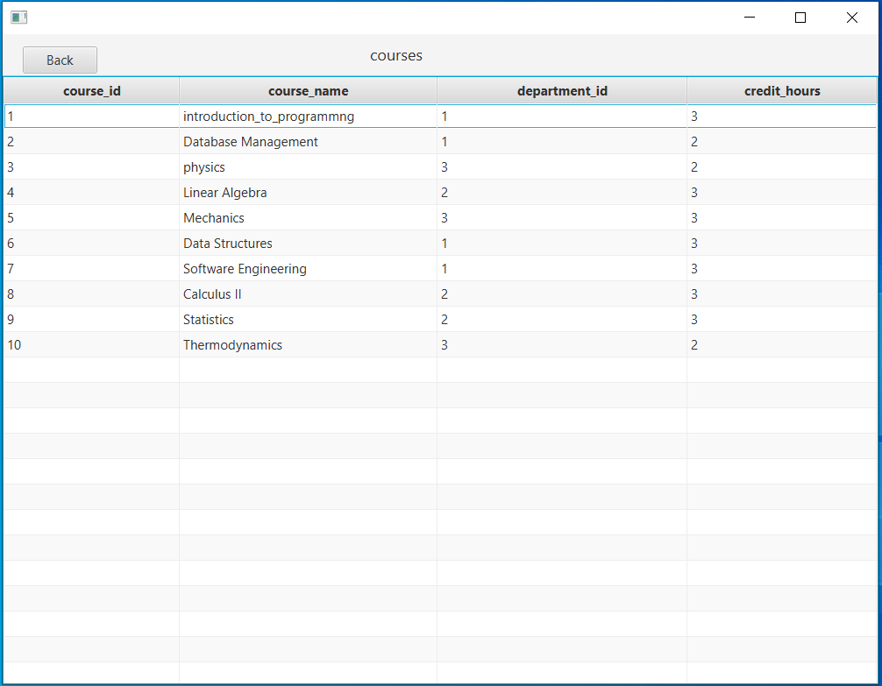

Departments scene :

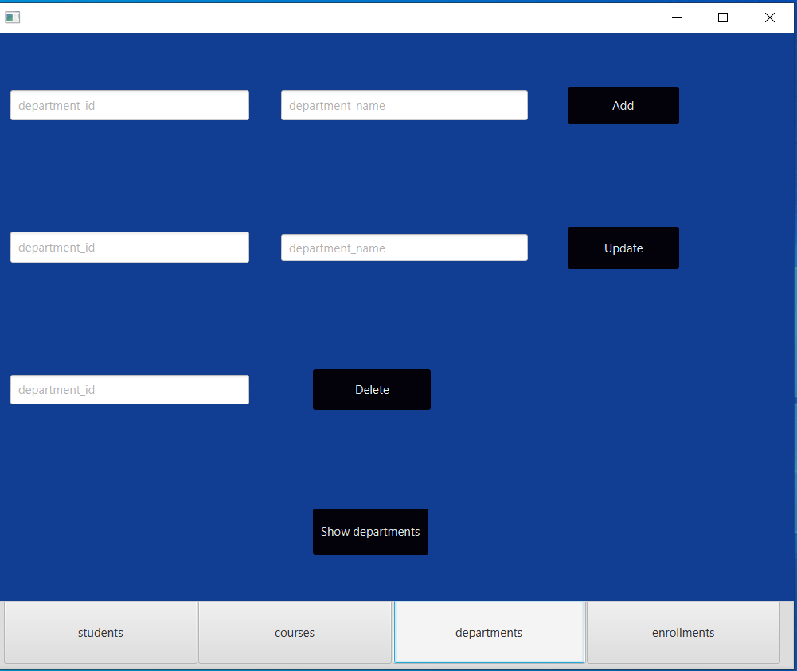

You can add , update and delete any department .. and you can also show departments data using show departments button which will redirects you to this scene :

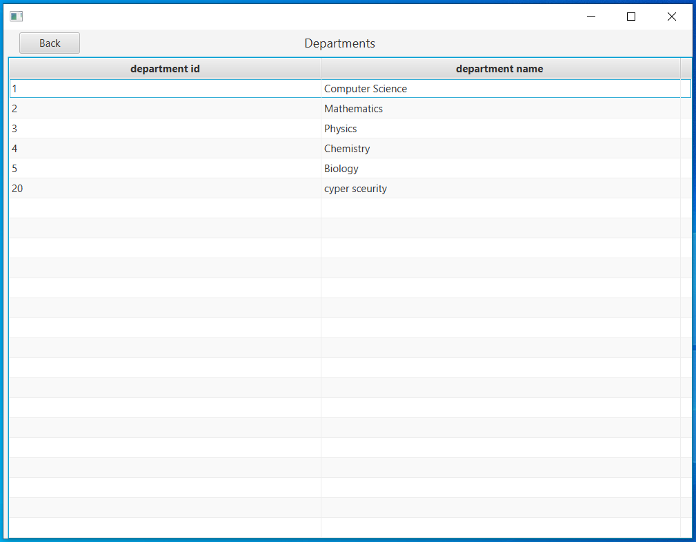

Enrollments scene :

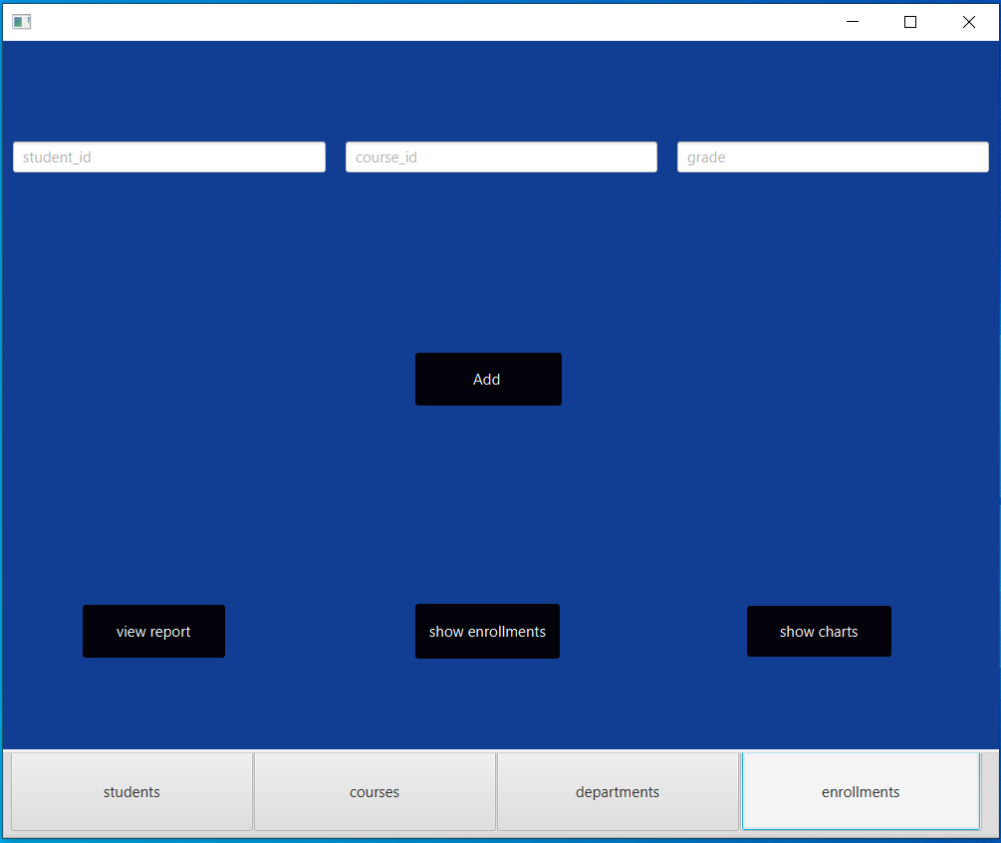

You only can add any enrollment.. once you added the enrollment record you can not update or delete it cause it is a final data .. you can also show enrollments data using show enrollments button which will redirects you to this scene :

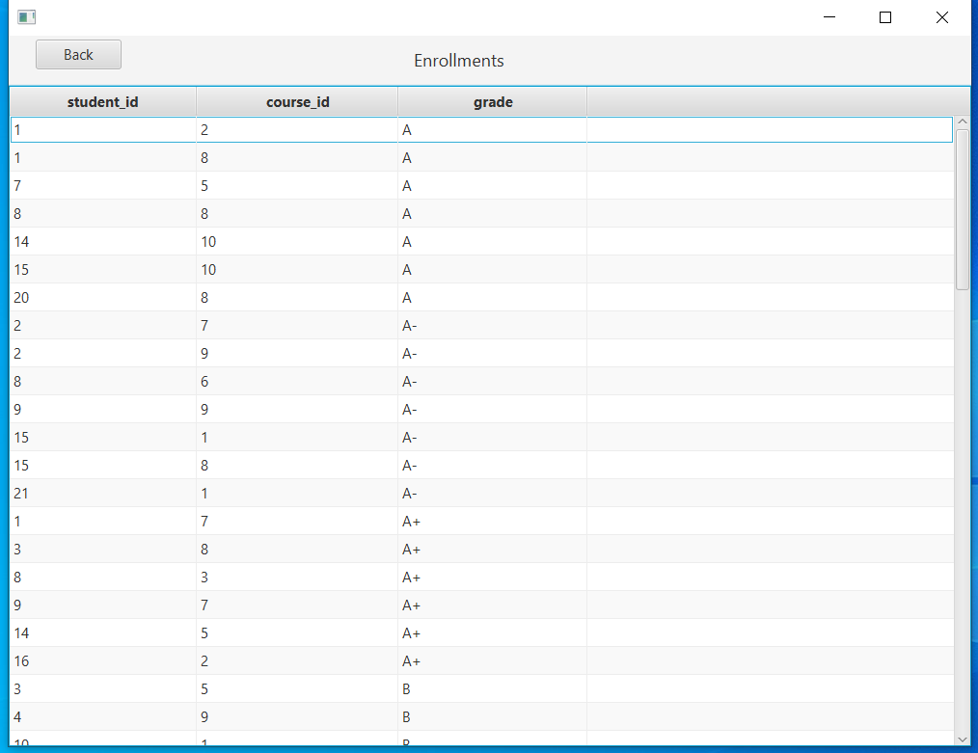

You can show report ( about each course and the number of students who enrolled in it and their average gpa in this course ) using the show report button in enrollments scene .. which will redirects you to this scene :

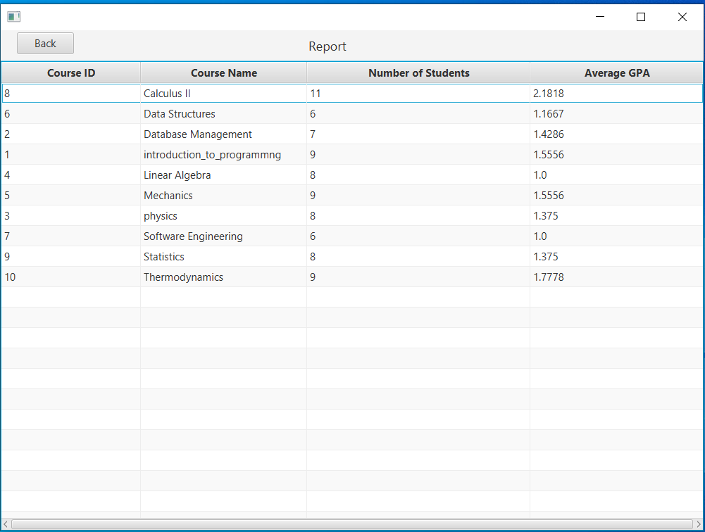

You can show some charts about grades frequency and courses frequency using the show charts button in enrollments scene .. which will shows this pop-up to you :

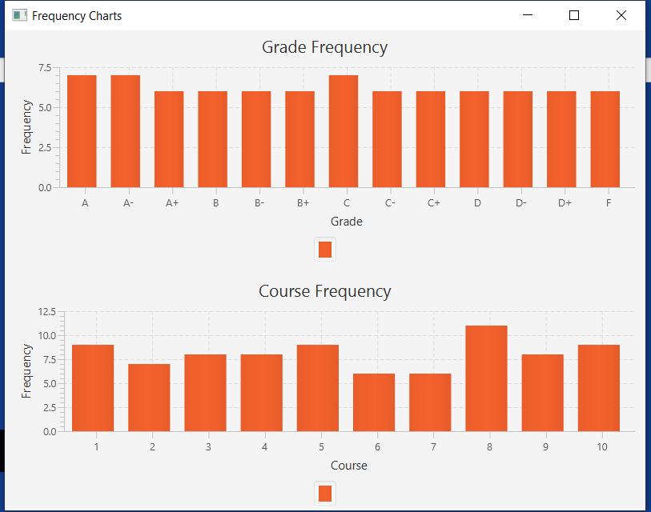

# **-Validations and alerts**

I tried to make many checks as possible as I could to guarantee the accuracy of the database

So I handled many cases with alerts prevent violating the database :

1. When you try to update a student who does not exist :

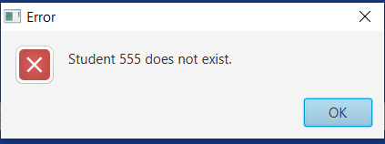

1. When you try to delete a student who does not exist :

1. When you try add a student with used student id :

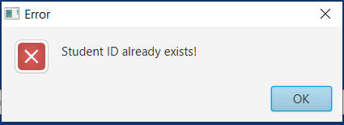

1. When you try to delete a student who is enrolled in one or more courses :

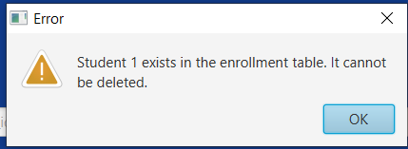

1. When you try to update a course who does not exist : 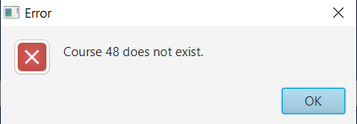
2. When you try to delete a course who does not exist :

1. When you try add a course with used course id :

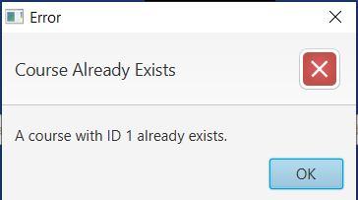

1. When you try to add a course with department id which does not exist in departments table :

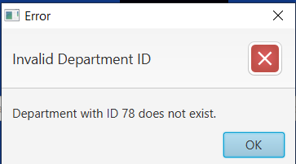

1. When you try to delete a course which is being enrolled by one or more students :

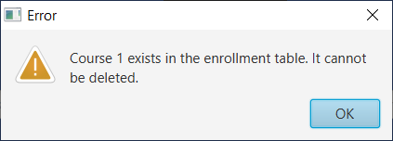

1. When you try to update a department who does not exist :

1. When you try to delete a department who does not exist :

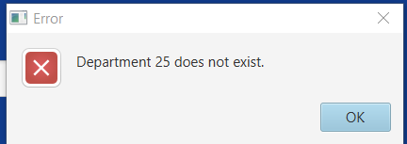

12 - When you try add a department with used department id:

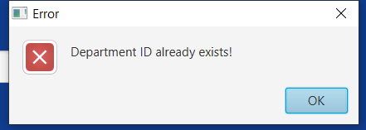

13 - When you try to delete a department which provide one or more courses :

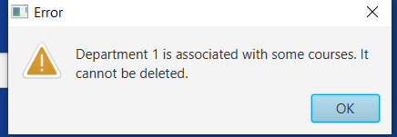

14 – when you try to add enrollment with a student_id which does not exist in students table :

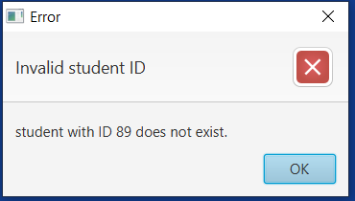

15 - when you try to add enrollment with a course_id which does not exist in courses table:

16- when you try to add enrollment with a grade which does not exist in grades table:

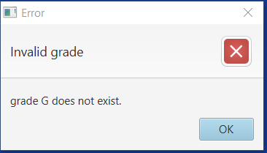

17 – when you try to add enrollment with a student_id and course id combination which already exists (once the student enrolled in a course he can not retake the course so the application does not accept any duplicates in (student_id, course_id) combination ):

